An Improved- SPIN Protocol for Wireless Sensor Networks
¹Shanti, ²k sujatha,³k mahesh
^{1,2,3}( ECE Dept, Sree Dattha Institute of Engineering and Science)

ABSTRACT
In Wireless Sensor Networks(WSN) data transmission is one the major challenges and a number of routing protocols have been proposed to cope up with this problem by saving energy during transmission. Routing protocols that performs in-network aggregation are best suited for this purpose to yield energy saving Data Transmission.
In this paper we are proposing an improved version of M-SPIN protocol named “I-SPIN” protocol. Our protocol aims at disseminating data to the sink node through shortest path in such a way that the load is uniformly distributed among all the nodes lying in the path and hence the probability of the nodes of being dead is almost same. Thus we don‟t have to calculate the shortest path as frequently as in M-SPIN protocol and all the sensor nodes in the network are utilized almost equally. Also I-SPIN protocol is more reliable than M-SPIN because the decay time of the sensor nodes is increased.

Keywords- WSN, routing protocols, SPIN

INTRODUCTION
Wireless sensor networks(WSN) is a network consist of very large number of sensor nodes which are much small in size,low construction cost and have limited memory and energy supply. But sensor nodes have the capability of sensing, computing and can perform wireless data transmission. Each node is smaller in size and communicates with other nodes in short range distance.
Sensor networks can be deployed for health monitoring, various industrial usages, air traffic monitoring, under water sensing and robot sensing control. Sensor technology is one of the cheapest technologies to provide security in very restrictive environments. These kinds of technologies are gaining popularity day by day due to best efficiency of security and low cost. The practice of remote sensing has become greatly simplified by useful and affordable sensors as well as required software packages. Additionally, users can keep an eye on the changing environment conditions even from a remote location.
In order to monitor changes effectively information must be transmitted from source node to sink node without loss of data and in an cost effective and energy saving manner. So, these are the vital considerations in any routing protocol. The wide ranges of applications that can be deployed on top of WSN make it difficult to develop a single routing protocol [1]. The design of the routing protocol is strictly dependent on the nature of the application requirements. Recent researches in this area also targets on routing algorithms designed for achieving better performance that saves energy of nodes and provide longer network lifetime.
Traditional routing protocols are address-centric. Here packets are routed based on unique IP addresses and data payload remains unchanged during the data delivery process. But this type of addressing scheme is not suitable for WSN, because it is hard to globally identify the sensor nodes in the network. Again due to energy and storage constraints of sensor nodes, redundant data are processed before their transmission.[1]
As WSNs are qualitatively different from traditional network, they need a different routing approach for their data to route. Data-centric routing is one of them. Since most WSNs are application specific it is relatively advantageous to concentrate on data content rather that address. In data-centric routing scheme, data are retrieved through querying. Querying the data is based on some of their attributes values. In this type of routing protocol, advertisement or interest for data is propagated throughout the network. [1]

II. TRADITIONAL SPIN PROTOCOL
SPIN (Sensor Protocols for Information via negotiation), is a family of negotiation-based information dissemination protocols suitable for wireless sensor networks. This is a straightforward protocol requiring no protocol state at any node, and it disseminates data quickly in a network where bandwidth is not scarce and links are not loss-prone. This section presents the individual elements that make up the SPIN family of protocols and presents two SPIN protocols that we have designed, SPIN-BC and SPIN- EC.[1]

Meta-Data:
Sensors use meta-data to succinctly and completely describe the data that they collect. If x is the meta-data descriptor for sensor data X , then the size of x in bytes must be shorter than the size of X , for SPIN to be beneficial. If two pieces of actual data are distinguishable, then their corresponding meta-data should be distinguishable. Likewise, two pieces of indistinguishable data should share the same meta-data representation.[1]
SPIN does not specify a format for meta-data; this format is application-specific. Sensors that cover disjoint geographic regions may simply use their own unique IDs as meta-data. The meta-data x would then stand for “all the data gathered by sensor x ”. A camera sensor, in contrast, might use (x,y,fi)as meta-data, where (x,y) is a geographic coordinate and „fi‟ is an orientation. Because each application‟s meta-data format may be different, SPIN relies on each application to interpret and synthesize its own meta-data.

SPIN Messages:
SPIN nodes use three types of messages to communicate:
ADV – new data advertisement. When a SPIN node has data to share, it can advertise this fact by transmitting an ADV message containing meta-data.
REQ – request for data. A SPIN node sends a REQ message when it wishes to receive some actual data.
DATA – data message. DATA messages contain actual sensor data with a meta-data header. Because ADV and REQ messages contain only metadata, they are smaller, and cheaper to send and receive than their corresponding DATA messages.[6]

SPIN Resource Management:
SPIN applications are resource-aware and resource adaptive. They can poll their system resources to find out how much energy is available to them. They can also calculate the cost, in terms of energy, of performing computations and sending and receiving data over the network. With this information, SPIN nodes can make informed decisions about using their resources effectively. [6]

SPIN-BC: A 3-Stage Handshake Protocol
[6]The SPIN-BC protocol is a simple handshake protocol for disseminating data through a lossless network. It works in three stages (ADV-REQ-DATA), with each stage corresponding to one of the messages described above. The protocol starts when a node obtains new data that it is willing to disseminate. It does this by sending an ADV message to its neighbors, naming the new data (ADV stage).Upon receiving an ADV, the neighboring node checks to see whether it has already received or requested the advertised data. If not, it responds by sending an REQ message for the missing data back to the sender (REQ stage). The protocol completes when the initiator of the protocol responds to the REQ with a DATA message, containing the missing data (DATA stage).
Figure 1 shows an example of the protocol. Upon receiving an ADV packet from node A, node B checks to see whether it possesses all of the advertised data (a). If not, node B sends an REQ message back to A, listing all of the data that it would like to acquire.
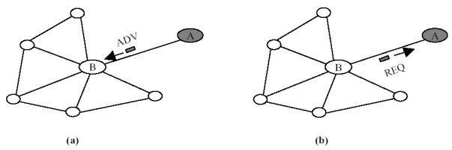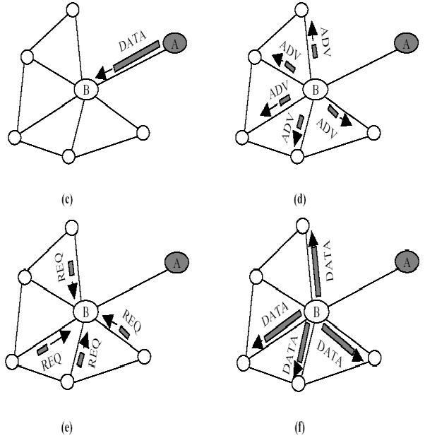

Figure 3: The SPIN-BC Protocol. Node A starts by advertising its data to node B (a). Node B responds by sending a request to node A (b). After receiving the requested data (c), node B then sends out advertisements to its neighbors (d), who in turn send requests back to B (e,f).

(b). When node A receives the REQ packet, it retrieves the requested data and sends it back to node B as a DATA message (c). Node B,in turn, sends ADV messages advertising the new data it received from nodeA to all of its neighbors (d). It does not send an advertisement back to node A, because it knows that node A already has the data. These nodes then send advertisements of the new data to all of their neighbors, and the protocol continues.
There are several important things to note about this example. First, if node B had its own data, it could aggregate this with the data of node A and send advertisements of the aggregated data to all of its neighbors (d). Second, nodes are not required to respond to every message in the protocol. In this example, one neighbor does not send an REQ packet back to node B (e). This would occur if that node already possessed the data being advertised.
Though this protocol has been designed for lossless networks, it can easily be adapted to work in lossy or mobile networks. Here, nodes could compensate for lost ADV messages by re-advertising these messages periodically. Nodes can compensate for lost REQ and DATA messages by re-requesting data items that do not arrive within a fixed time period. For mobile networks, changes in the local topology can trigger updates to a node‟s neighbor list. If a node notices that its neighbor list has changed, it can spontaneously re-advertise all of its data.
This protocol‟s strength is its simplicity. Each node in the network performs little decision making when it receives new data, and therefore wastes little energy in computation. Furthermore, each node only needs to know about its single-hop network neighbors. The fact that no other topology information is required to run the algorithm has some important consequences. First, SPIN-BC can be run in a completely unconfigured network with a small, startup cost to determine nearest neighbors. Second, if the topology of the network changes frequently,these changes only have to travel one hop before the nodes can continue running the algorithm.
SPIN-EC, SPIN-BC with a Low-Energy Threshold The SPIN-EC protocol adds a simple energy- conservation heuristic to the SPIN-BC protocol. When energy is plentiful, SPIN-EC nodes communicate using the same 3-stage protocol as SPIN-BC nodes. When a SPIN-EC node observes that its energy is approaching a low-energy threshold, it adapts by reducing its participation in the protocol. In general, a node will only participate in a stage of the protocol if it believes that it can complete all the other stages of the protocol without going below the low-energy threshold. This conservative approach implies that, if a node receives some new data, it only initiates the three-stage protocol if it believes it has enough energy to participate in the full protocol with all of its neighbors. Similarly, if a node receives an advertisement, it does not send out a request if it does not have enough energy to transmit the request and receive the corresponding data. This approach does not prevent a node from receiving, and therefore expending energy on, ADV or REQ messages below its low-energy threshold. It does, however, prevent the node from ever handling a DATA message below this threshold.[1]

III. MODIFIED SPIN PROTOCOL(M-SPIN)
In few applications such as alarm monitoring applications need quick and reliable responses. Suppose in forest fire warning system, quick response is needed before any disaster occurs. In this case, it is desirable
that data must be disseminated towards the sink node very quickly.[1]
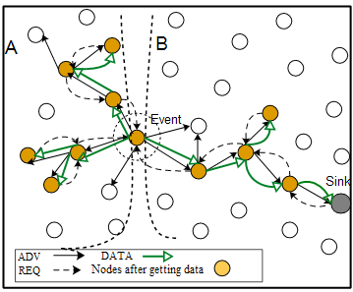

Figure 2. Data Transmission in a Wireless Sensor Network
M-SPIN routing protocol is better approach for such type of applications than SPIN. In M-SPIN, we add a new phase called Distance discovery to find distance of each sensor node in the network from the sink node in terms of hops. This means that nodes having higher value of hop distance are far away from the sink node. Other phases of M-SPIN are Negotiation and Data transmission. On the basis of hop distance, Negotiation is done for sending an actual data. Therefore, use of hop value controls dissemination of data in the network. Finally, data is transmitted to the sink node.Here the main advantage was that data is transmitted to only those nodes that are residing in the path ending at the sink node.Thus, prevents the extra burdon to transmit data to all tha sensor nodes and saving a significant amount of energy.[1]

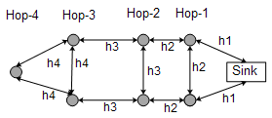

Figure 3. Distance Discovery Phase
Figure 2 shows the Distance discovery phase of M- SPIN. Hop distance is measured from sink nodes. Initially the sink node broadcasts Startup packet in the network with type ,nodeId and hop. Here type means type of messages. The nodeId represents id of the sending node and hop represents hop distance from the sink node. Initial value of hop is set to 1.When a sensor node receives the Startup packet, it stores this hop value as its hop distance from the sink node in memory. After storing the value, the sensor node increases the hop value by 1 and then re-broadcast the Startup packet to its neighbour nodes with modified hop value. It may also be possible for a sensor node to receive multiple Startup packets from different intermediate nodes
Whenever a sensor node b receives Startup packets from its neighbors ai, 1 ≤ i ≤ n, it checks the hop distances and set the distance to the minimum, i.e.
h(a b) i n} i min ∀ , , = 1,

Where h(a b) i , represents hop distances between the nodes ai and b and n is the no. of neighbor nodes of node b from which it receives the startup packets.
The Negotiation phase is almost similar to the SPIN-BC protocol. The source node sends an ADV message. Upon receiving an ADV message, each neighbour node verifies whether it has already received or requested the advertised data. Not only that, receiver node also verifies whether it is nearer to the sink node or not in comparison with the node that has sent the ADV message. This is the main difference between the negotiation phase of SPIN_BC and that of M-SPIN. If hop distance of the receiving node (own_hop) is less than the hop distance received by it as part of the ADV message (rcev_hop), i.e. own_hop < rcev_hop, then the receiving nodes send REQ message to the sending node for current data. The sending node then sends the actual data to the requesting node using DATA message.[1] The Data transmission phase is same as SPIN-BC protocol. After request is received by the source node, data is immediately sent to the requesting node.
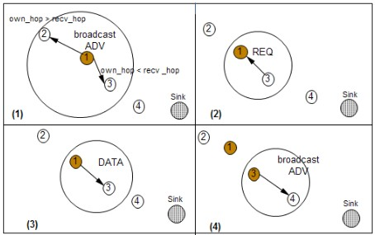

Figure 4. The M-SPIN protocol. (1) Node 1 starts advertising its data to all of its neighbors. (2) Node 3 responds by sending a request to node 1. (3) After receiving the request, node 1 sends the data. (4) Node 3 again sends advertisement out to its neighbors for the data that it received from node 1.
IV. PROPOSED WORK

Improved-SPIN Protocol (I-SPIN)
Our protocol I-SPIN undertakes all the advantages of M-SPIN protocol But removes the major disadvantage.In our proposed protocol also the Negotiation phase and data transmission phase will be same as in M-SPIN protocol but we have modified the Distance Discovery phase to remove the demerits.
As in modified SPIN (M-SPIN), here also negotiation is done before sending the actual data. But in our scheme, only the nodes which lie in a shortest path to sink node send REQ packets in response to ADV packet from the source node. Therefore data is disseminated to the sink or neighbour nodes towards the sink node. I-SPIN achieves energy savings by discarding packet transmission to the opposite direction of sink node.
The problem of M-spin protocol is that few sensor nodes may be used several times and may be destroyed earlier than other nodes in the network and we have to calculate the shortest path every time a sensor node destroyed in the network. Thus no data transmission will be done until we calculate the next shortest path. In I-SPIN protocol we calculate shortest path from sink node to all other nodes in the network only one time at the beginning of the protocol .
In I-SPIN protocol we are using the Bellman-Ford Algorithm to calculate the shortest path through which data is transmitted to the sink node.

Distance Discovery Phase:
Working of this phase is explained by following figure:
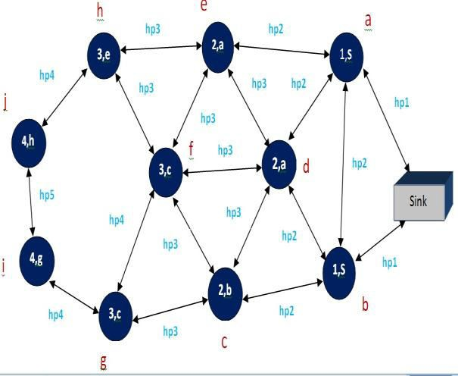

Figure:5 Distance Discovery Phase of I-SPIN Protocol
Requirement:
Except the neighbours of sink nodes each node in the network will contain three variables hp-val(shortest distance from sink), hp-id(id of node coming first in shortest path), counter(initially 1) and a table named SAR(having max 2 columns).

Steps:
Steps of the Distance discovery phase is as follows:
- Initially the sink node broadcasts Startup packet in the network with type, node-Id and hop .Here type means type of messages. The node-Id represents id of the sending node and hop represents hop distance from the sink node. Initial value of hop is set to 1.[1]
- When a sensor node receives the Startup packet, it stores this hop value in hp-val and node-id in hp-id. After storing the value, the sensor node increments the hop value by 1 and then re-broadcast the Startup packet to its neighbour nodes with modified hop value. It may also be possible for a sensor node to receive multiple Startup packets from different intermediate nodes. . Whenever a sensor node b receives Startup packets from its neighbour a it compares the hop value with hp-val and set the hp- val to the minimum and update hp-id as well.
- If hp- val=hop-value, node b adds hp-val as first column head of table SAR and write hp-val as first row,then second row and so on if same is repeated again.
- If hp- val + 1=hop-value , node b adds hp-val as second column head of table SAR and write hp-val as first row,then second row and so on if same is repeated again.
After the end of Distance Discovery phase,All nodes in the network have the shortest path length to sink node.The values of hp-val and hp-id of all nodes is shown in figure-4 itself whereas the tables of all nodes according to figure-4, are as follows:

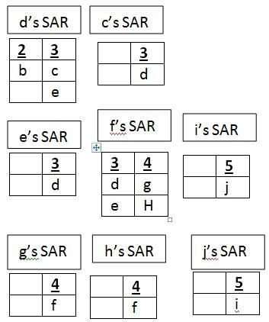

- if the value=1,then node-h will transmit the packet to node having hp-id as its node id i.e node-e in this case and then increment counter.
- if the value=2,then node-h will check its SAR table for column having head=hp-val and head = hp-val+1. if only hp-val column is present then it will randomly select one of the node-id from any row and transmit data to it. Then decrement the counter.
else if column with head=hp-val is not present but column with head=hp-val +1 is present then it will randomly select one of the node-id from any row of it and transmit data to it.Then decrement the counter.
else if no column is there then it will forward the packet to node having hp-id as its node id and decrement the counter.
else if both are present then it will randomly select one of the node-id from any row of hp-val column and transmit data to it.Then increment the counter.
- if the value=3(i.e both columns are present) then it will randomly select one of the node-id from any row of hp-val +1 column and transmit data to it.Then set counter=1.
Any of the intermediate node will follow the steps ab & c until data is received by sink node.Data transmission to any node is done through negotiation.

Failure resistant I-SPIN:
If any of the node fails:
a) before sending actual data a node-h will send ADV msg to target node only.on receving ADV msg target node will send REQ msg to node-h .
If node –h will receive the REQ msg then only it will transmit actual data
Otherwise node-h will remove that node-id and follow any of the steps a,b or c whichever is applicable. Data transmission will not stop even after failure of any node

Advantage:
- As we are randomly selecting intermediate nodes, No node will get extra burdon on it and the probability of getting decayed will be divided almost equally among all the nodes.
- Due to random selection shortest path will also change for same node if it is transmitting again the second time, so above point will be for all nodes in network.
- We have to calculate the shortest path only one time during the starting of the Protocol.
- Transmission will not be stopped due to decay of any node as it will be simply eliminated from the PATH.
- Lifetime of WSN will increase.

REFERENCE
[1] Zeenat Rehena, Sarbani Roy , Nandini Mukherjee : A Modified SPIN for Wireless Sensor Networks , 978-1-4244-8953-4/11/ ©2011 IEEE
[2] K. Akkaya, M. Younis: A Survey on Routing Protocols for Wireless Sensor Networks. In: Elsevier Ad Hoc Network Journal, Vol. 3, pp. 325-349, 2005.
[3] I.F. Akyildiz, M.C. Vuran, O. Akan, W. Su: Wireless Sensor Networks: A Survey Revisited. In: Computer Networks Journal (Elsevier Science),Vol. 45, no. 3, 2004.
[4] J. Kulik, W.R. Heinzelman, H. Balakrishnan: Negotiation–Based Protocols for Disseminating Information in Wireless Sensor Networks, Vol 8, pp. 169-185, 2002.
[5] F. Zabin, S. Misra, I. Woungang, H.F. Rashvand,
N.W. Ma, M. A. Ali:REEP: data-centric, energy- efficient and reliable routing protocol for wireless sensor networks. In: IET Commun. Vol. 2, No. 8, pp. 995-1008,2008
[6] Adaptive Protocols for Information Dissemination in Wireless Sensor Networks Joanna Kulik,Wendi Rabiner, and Hari Balakrishnan,1999

Working of I-SPIN:
Suppose node-h is the source and has to send data packet to sink node-s.Then it will do following steps: Check the value of counter variable

Headings
The headings and subheadings, starting with "1. Introduction", appear in upper and lower case letters and should be set in bold and aligned flush left. All headings from the Introduction to Acknowledgements are numbered sequentially using 1, 2, 3, etc. Subheadings are numbered 1.1, 1.2, etc. If a subsection must be further divided, the numbers 1.1.1, 1.1.2, etc.
The font size for heading is 11 points bold face and subsections with 10 points and not bold. Do not underline any of the headings, or add dashes, colons, etc.

Indentations and Equations
The first paragraph under each heading or subheading should be flush left, and subsequent paragraphs should have
a five-space indentation. A colon is inserted before an equation is presented, but there is no punctuation following the equation. All equations are numbered and referred to in the text solely by a number enclosed in a round bracket (i.e., (3) reads as "equation 3"). Ensure that any miscellaneous numbering system you use in your paper cannot be confused with a reference [4] or an equation (3) designation.

Figures and Tables
To ensure a high-quality product, diagrams and lettering MUST be either computer-drafted or drawn using India ink.
Figure captions appear below the figure, are flush left, and are in lower case letters. When referring to a figure in the body of the text, the abbreviation "Fig." is used. Figures should be numbered in the order they appear in the text.
Table captions appear centered above the table in upper and lower case letters. When referring to a table in the text, no abbreviation is used and "Table" is capitalized.

Conclusion
A conclusion section must be included and should indicate clearly the advantages, limitations, and possible applications of the paper. Although a conclusion may review the main points of the paper, do not replicate the abstract as the conclusion. A conclusion might elaborate on the importance of the work or suggest applications and extensions.

Acknowledgements
An acknowledgement section may be presented after the conclusion, if desired.

References
This heading is not assigned a number.
A reference list MUST be included using the following information as a guide. Only cited text references are included. Each reference is referred to in the text by a number enclosed in a square bracket (i.e., [3]). References must be numbered and ordered according to where they are first mentioned in the paper, NOT alphabetically.
Examples follow:
Journal Papers:
- M Ozaki, Y. Adachi, Y. Iwahori, and N. Ishii, Application of fuzzy theory to writer recognition of Chinese characters, IOSR Journal of Engineering, 2(2), 2012, 112-116.

Note that the journal title, volume number and issue number are set in italics.
Books:
- R.E. Moore, Interval analysis (Englewood Cliffs, NJ: Prentice-Hall, 1966).

Note that the title of the book is in lower case letters and italicized. There is no comma following the title. Place of publication and publisher are given.
Chapters in Books:
- P.O. Bishop, Neurophysiology of binocular vision, in J.Houseman (Ed.), Handbook of physiology, 4 (New York: Springer-Verlag, 1970) 342-366.

Note that the place of publication, publisher, and year of publication are enclosed in brackets. Editor of book is listed before book title.
Theses:
- D.S. Chan, Theory and implementation of multidimensional discrete systems for signal processing, doctoral diss., Massachusetts Institute of Technology, Cambridge, MA, 1978.

Note that thesis title is set in italics and the university that granted the degree is listed along with location information
Proceedings Papers:
- W.J. Book, Modelling design and control of flexible manipulator arms: A tutorial review, Proc. 29th IEEE Conf. on Decision and Control, San Francisco, CA, 1990, 500-506.

Note that the proceedings title is set in italic

Send your Manuscript to Inventy@editormails.com
for further peer review process.

